**Cucumber Project**

**Pom.xml**

<project xmlns="http://maven.apache.org/POM/4.0.0" xmlns:xsi="http://www.w3.org/2001/XMLSchema-instance" xsi:schemaLocation="http://maven.apache.org/POM/4.0.0 https://maven.apache.org/xsd/maven-4.0.0.xsd">

<modelVersion>4.0.0</modelVersion>

<groupId>Cucjava</groupId>

<artifactId>Cucjava</artifactId>

<version>0.0.1-SNAPSHOT</version>

<dependencies>

<!-- https://mvnrepository.com/artifact/io.cucumber/cucumber-java -->

<dependency>

<groupId>io.cucumber</groupId>

<artifactId>cucumber-java</artifactId>

<version>7.9.0</version>

</dependency>

<!-- https://mvnrepository.com/artifact/junit/junit -->

<dependency>

<groupId>junit</groupId>

<artifactId>junit</artifactId>

<version>4.13.1</version>

<scope>test</scope>

</dependency>

<!-- https://mvnrepository.com/artifact/io.cucumber/cucumber-junit -->

<dependency>

<groupId>io.cucumber</groupId>

<artifactId>cucumber-junit</artifactId>

<version>7.9.0</version>

<scope>test</scope>

</dependency>

</dependencies>

**Login.feature**

#Author

#Date

#Description

Feature: feature to test Login functionality

Scenario: Check login is Successful with valid credentials

Given user is on Login page

When user enters username and password

And clicks on login button

Then user is navigated to the home page

**Screenshot:**

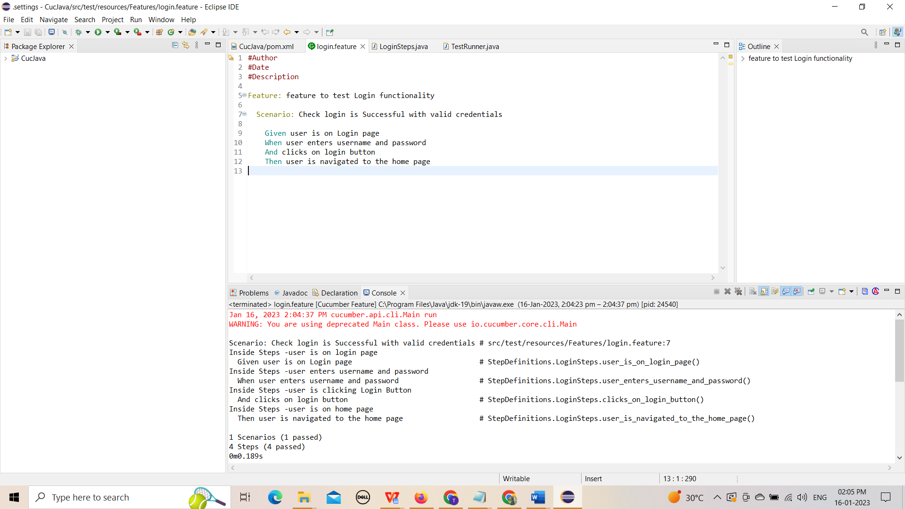

**LoginSteps.java**

package StepDefinitions;

import io.cucumber.java.en.And;

import io.cucumber.java.en.Given;

import io.cucumber.java.en.Then;

import io.cucumber.java.en.When;

public class LoginSteps {

@Given("user is on Login page")

public void user_is_on_login_page() {

System.out.println("Inside Steps -user is on login page");

}

@When("user enters username and password")

public void user_enters_username_and_password() {

System.out.println("Inside Steps -user enters username and password");

}

@And("clicks on login button")

public void clicks_on_login_button() {

System.out.println("Inside Steps -user is clicking Login Button");

}

@Then("user is navigated to the home page")

public void user_is_navigated_to_the_home_page() {

System.out.println("Inside Steps -user is on home page");

}

}

**Screenshot:**

